# CS 255 System Design Document Template

This template lays out all the different sections that you need to complete for Project Two. Each section has guidance to prompt your thinking. You will need to continually reference the interview transcript as you work to make sure that you are addressing your client’s needs. There is no required length for the final document. Instead the goal is to complete each section based on what your client’s needs are. Remove this note when you are finished, and replace all bracketed text with the relevant information.

## UML Diagrams

### UML Use Case Diagram

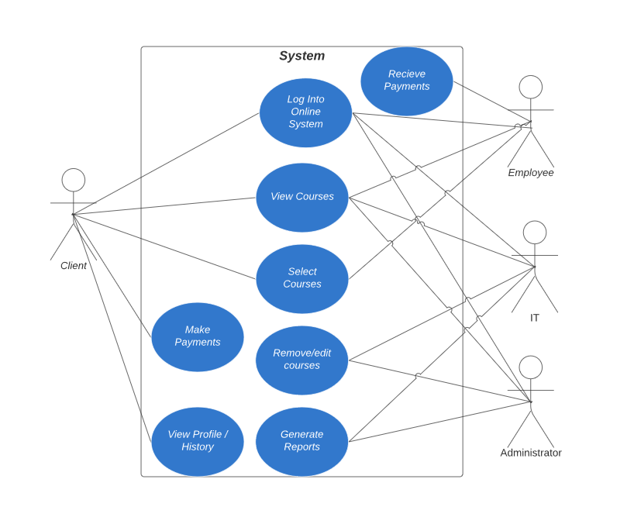

### UML Activity Diagrams

The first activity diagram is how a customer longs into the system and selects a course. The second activity diagram is how the customer completes an online payment.

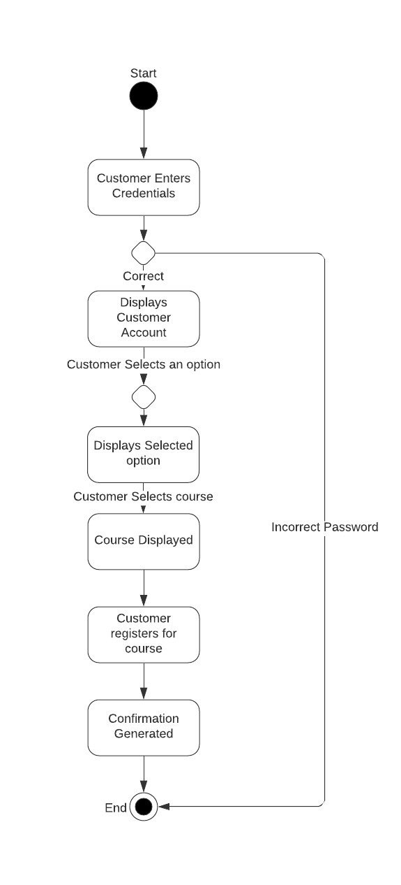

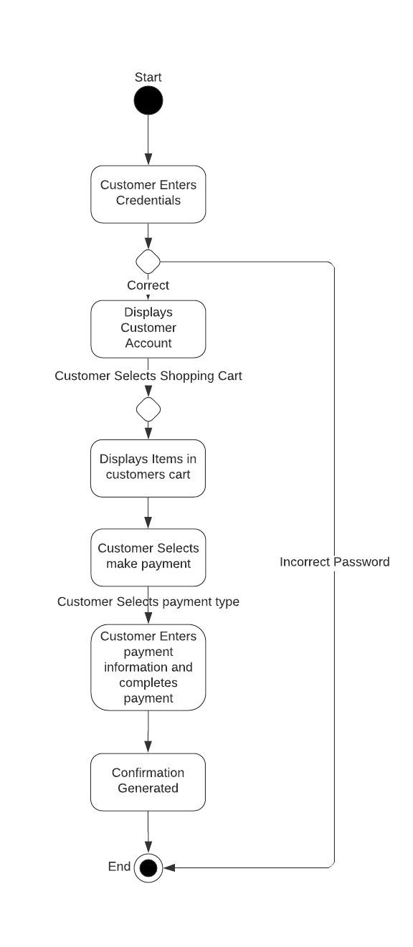

### UML Sequence Diagram

Sequence diagram of how a customer can select a course, how DriverPass is notified, and how the customer receives confirmation.

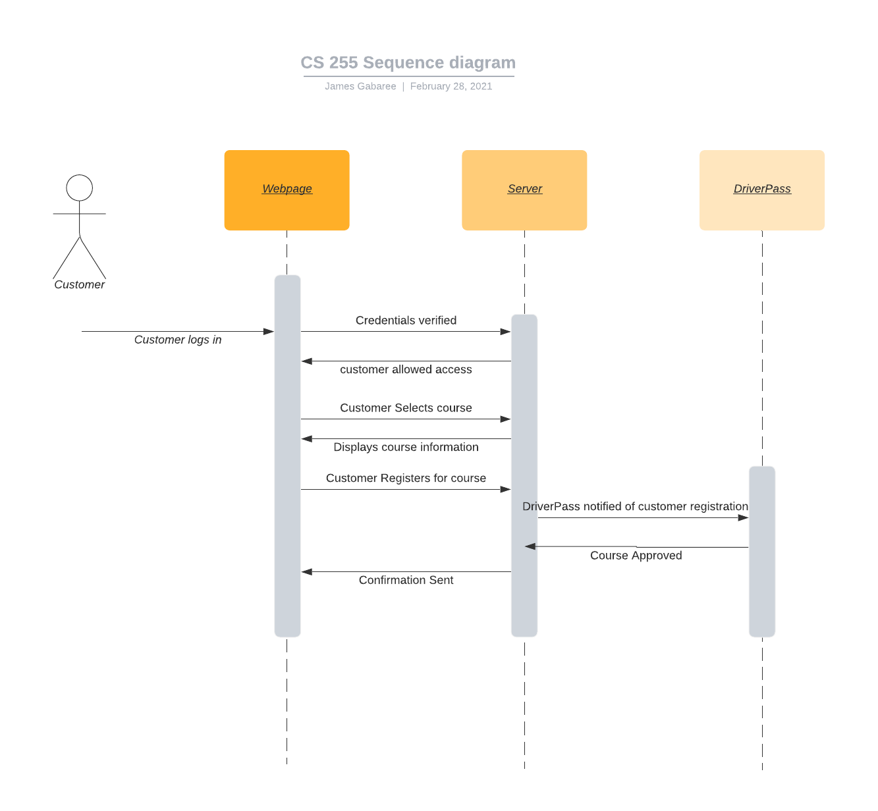

### UML Class Diagram

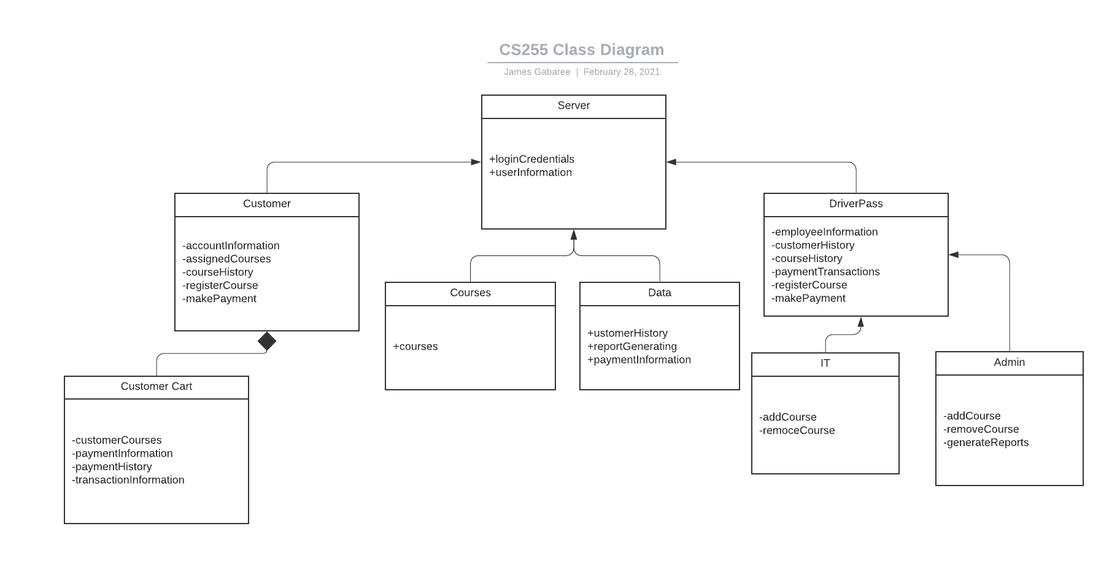

## Technical Requirements

The system will require the following requirements:

* Internet connection
* Device able to connect to the internet
* A data server or cloud storage
* A user interface
* A transaction system

Above are key components that are required for this project. With it being such a small operating process it should not require any specific hardware specification. A mobile device should be able to access the system via an internet connection. Storage will need to be maintained in order to have the proper reports, payment information, and course information for the customers and business. The program can be amended in the future to allow more access or alteration to the courses, but it is imperative that a course and be brought down if it does not fall within DMV guidelines. Cloud storage is recommended since the program is going to be run on multiple platforms from multiple different operating systems, and the data will need to be on demand from anywhere. With a program of this size it will be more cost effective to utilize hosted cloud storage opposed to purchasing and maintaining a dedicated server.